Compiled and deployed contract with top three accounts in Ganache

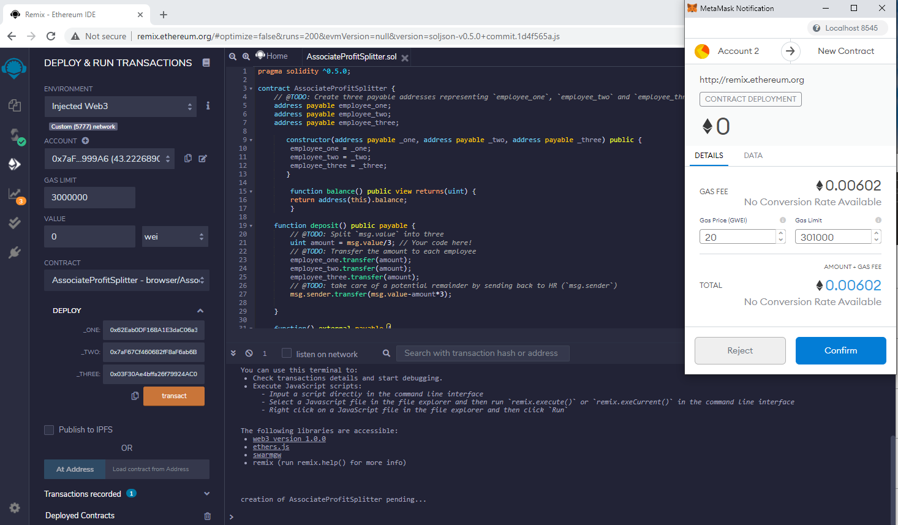

Making deposit of Ether from account 4 to be split between 3 associates with accounts 1, 2, 3

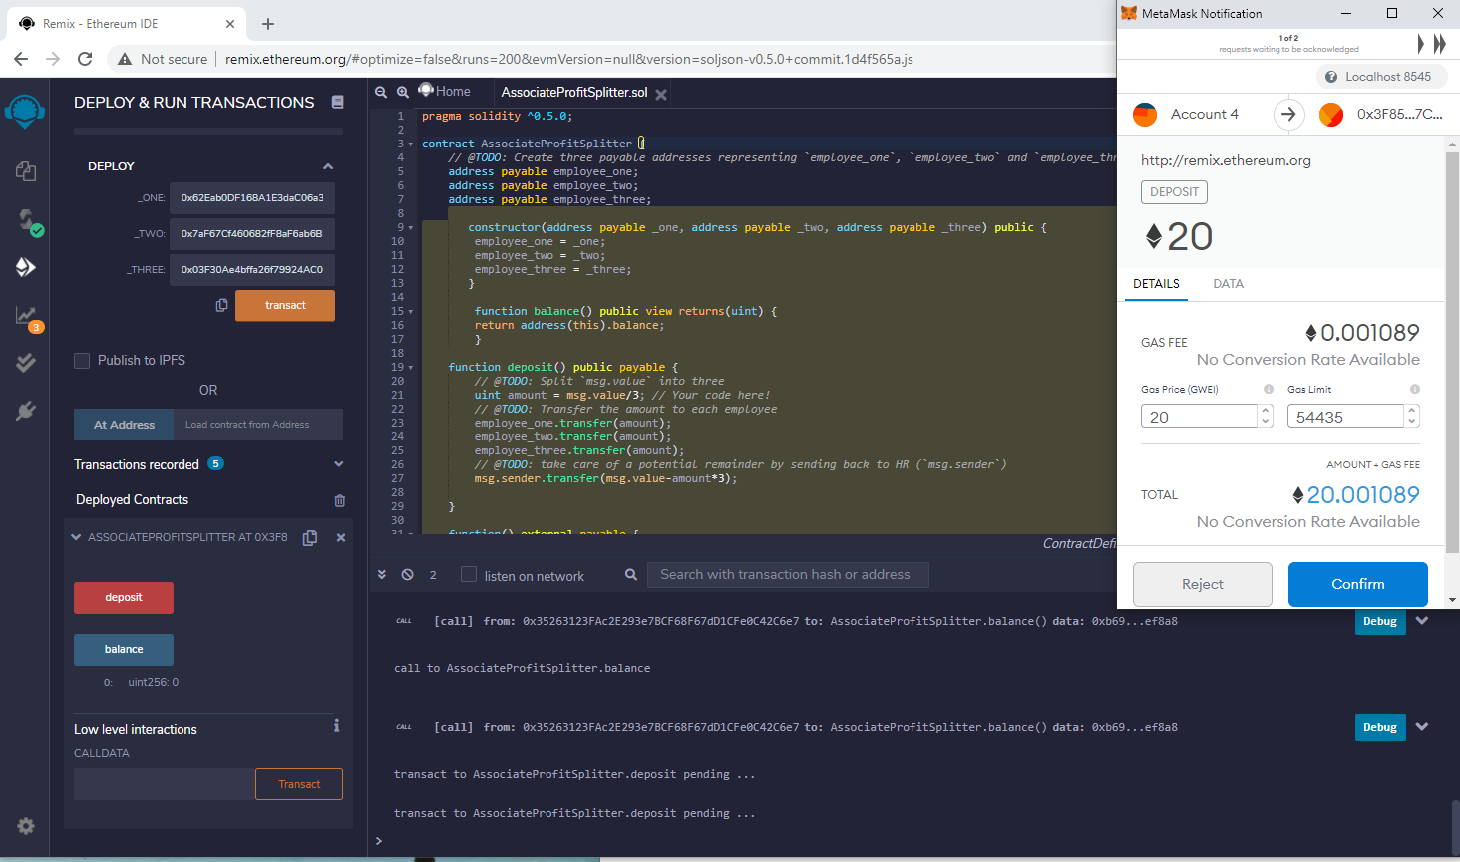

Before Deposit

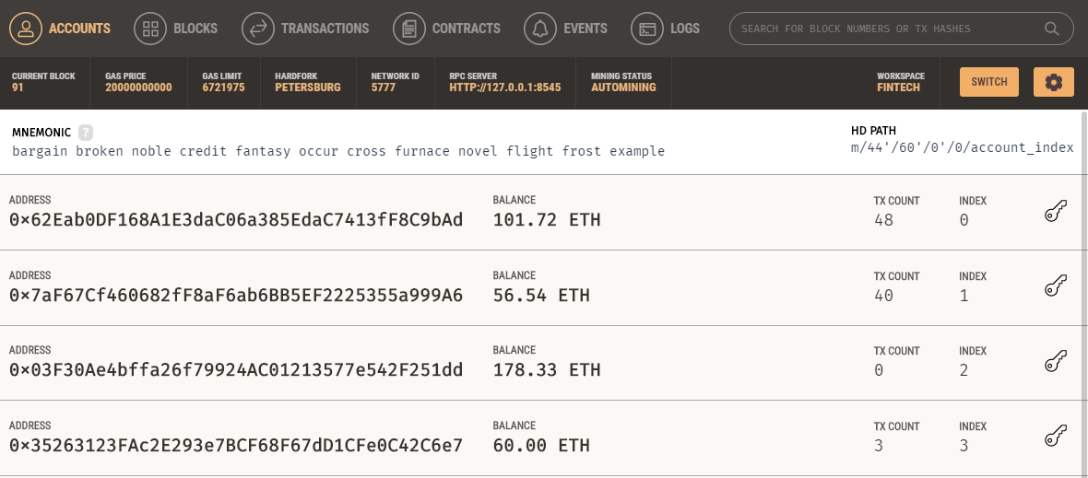

After deposit and split

